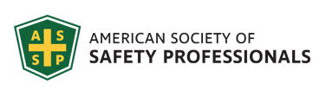
Southwestern Ohio Chapter News & Meeting Announcement - November 2021
Scheduled Meetings and Topics for 2021
November November 9th 12PM – 1 PM OSHA discussion with Ken Montgomery
December TBD Holiday Networking Event

Won’t you please join us virtually?
NOVEMBER MEETING TOPIC: OSHA Discussion with Ken Montgomery, OSHA Region V Area Director
Date: Tuesday November 30th
Meeting time: 11:30 PM – 1:00 PM
Speaker: Ken Montgomery, OSHA Region V Area Director
Location: online Please register online: https://swohio.assp.org/event/
SAVE THE DATE!
Friday June 17, 2022
SOUTH WEST OHIO CHAPTER SCHOLORSHIP FUNDRAISER
The chapter team is planning a sporting clays event scheduled for the Summer of 2022. This event will help the chapter to raise money for our scholarship fund. This money is used to help college students wishing to pursue a career in Environmental Health and Safety to get a little financial assistance through our local chapter.
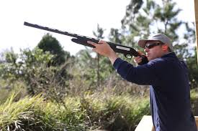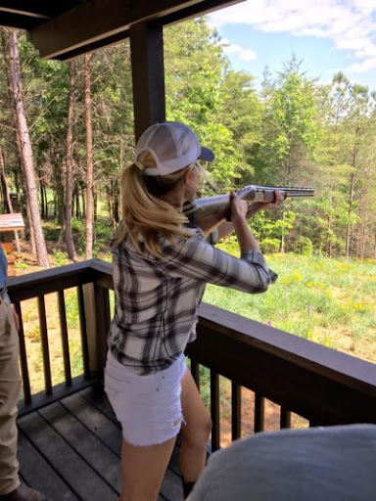
WE ARE LOOKING FOR SPONSORS FOR THE UPCOMING SCHOLORSHIP FUND RAISER

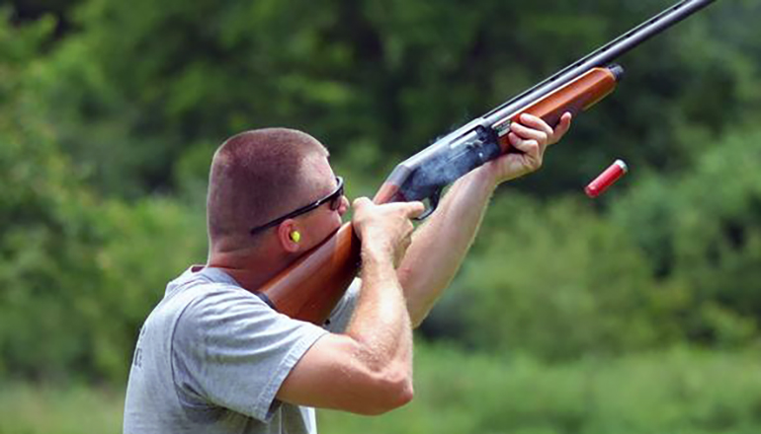

When: Friday June 17, 2022
Where: Sycamore Pheasant Club
What Time: 10:30 AM – 4:30 PM
Sponsorship Opportunities

Platinum Presenting Sponsor ($5,000)-1 Two teams of four shooters; Company name or logo on primary promotional banner which will be complimentary take home photo background for all team members; Opportunity to sponsor, speak and hand out awards at presentations ceremony; The opportunity to place multiple items in shooter gift bags; 2 shooting station signs; Placement in event signage and Chapter website and social media distributed to over 200+ ASSP chapter members.

Gold Sponsors ($4,000)-2 Two teams of four shooters; Company name or logo on primary promotional banner which will be complimentary take home photo for all team members; The opportunity to place one item in shooter gift bags;1 shooting station sign; Placement in Chapter website and social media distributed to over 200 +ASSP chapter members.
Ammunition Sponsors ($3,000)-2 One team of four shooters; Company name or logo sticker on all ammunition packs for event: The opportunity to place one item in shooter gift bags;1 shooting station sign; Placement in Chapter website and social media distributed to over 200+ ASSP chapter members. shooter gifts; shooting station sign; program and event signage.

Lunch Sponsor ($3,000)-1 One team of four shooters; Provides meal for all shooters; table tents with company name or logo during meal; The opportunity to place one item in shooter gift bags;1 shooting station sign; Placement in Chapter website and social media distributed to over 200 +ASSP chapter members.

Cart Sponsors ($2,500)-2 One team of four shooters; Company name or logo on 1 side of shooter team carts; The opportunity to place one item in shooter gift bags; Placement in Chapter website and social media distributed to over 200+ ASSP chapter members. * one sponsorship of $4,500 doubles Cart Sponsorship opportunity
Scorecard Sponsor ($2,000)-1 One team of four shooters; Company name or logo on all scorecards used by shooters; The opportunity to place one item in shooter gift bags; Placement in Chapter website and social media distributed to over 200+ ASSP chapter members. * one sponsorship of $3,000 sponsors both scorecard and closing reception opportunity.
Closing Reception Sponsor ($1,500) Provides snack foods, 2-adult beverages per person and soft Drinks for all shooters; table tents with company name or logo during closing reception; The opportunity to place one item in shooter gift bags; Placement in Chapter website and social media distributed to over 200+ ASSP chapter members.

Station Sponsor ($500.00) One prominent sign at one of the available shooting stations; The opportunity to place 1 item in shooter gift bags; Placement in event signage and Chapter website and social media distributed to over 200+ ASSP chapter members. * One sponsorship of $800 doubles Station Sponsorship opportunity, $900 triples the sponsorship opportunity.

Team Ticket to form a team ($1000.00) Company/individual can sponsor 4 participants at this entry fee amount; The opportunity to place 1 item in shooter gift bags; complimentary take home photo background for all team members. Payment in full for your team by April 30-2022 and receive $100.00 off team price!

Single Ticket to join a team ($275.00) Company/individual can sponsor a participant at this entry fee amount; No guarantee of a team. The opportunity to place 1 item in shooter gift bags. Payment in full for your individual ticket by April 30-2022 and receive $25.00 off individual price!
When you reply for more information, you can do so to
Bradford Weber Bob Gander

brad.weber@sheakley.com bobgander@jtmfoodgroup.com

513-314-0042 513-503-6089

Request for Hosts to Conduct
Plant Tours in 2022
If you and your company would be willing to host a plant tour next year, please let Brad Weber (Brad.Weber@sheakley.com or (513-314-0042) know and we can make arrangements to get it on our meeting calendar. That is a great opportunity to network with other safety professionals as well as share ideas and innovations across industries.
President’s Message

Building a Pipeline for the Future
Bradley D. Giles, P.E., CSP, STS, FASSP, GIOSH, 2021-2022 ASSP President
Oct 01, 2021
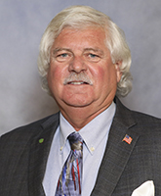
Like many of you, I was drawn to the OSH profession by personal experiences. My family members have been involved in coal mining for generations. My grandfather died in a mining incident before I was born, and my great-grandfather lost his life in a similar incident. In high school and during college, I worked as a construction laborer and ironworker. During graduate school, I taught police and ambulance personnel high-speed driving maneuvers.
Each of those experiences provided unique lessons that I have carried with me throughout my 45-year career in our profession. They also helped me appreciate how many different paths there are into safety and how important building and maintaining a pipeline of qualified safety practitioners is to our profession and our Society. I would like to briefly highlight just a few of those paths.
One common way into our field is to obtain a degree in safety or a related field. Academic programs are an important part of our profession’s pipeline. Through our work with organizations such as ABET and AIHA, we have long supported and helped define the standards used to accredit safety-related degree programs. While not all degree programs pursue ABET accreditation, this work is an important part of ASSP’s efforts to support the development of future professionals.
Emerging professionals bring new perspectives, ideas and energy into our workplaces. Each of us can serve as a resource to help them develop additional knowledge and skills and encourage them to pursue continuing education and professional certification. Throughout my career, I have enjoyed mentoring emerging professionals and helping them advance in their careers and develop into future ASSP leaders. If your chapter has a student section or members who are new to safety, please reach out and talk with them about your career, share lessons learned, provide support and help them understand what it is like to work in the safety profession.
We also know that individuals with backgrounds in the military, the trades, business, education and engineering have skills that can help them become effective safety professionals. I have long advocated for veterans to consider workplace safety as a second career. Their experience with leadership, teamwork, risk assessment, communication and problem-solving align well with the safety profession. The trades are another potential source of future safety professionals. Tradespeople have firsthand knowledge and real-world experience performing work safely in a wide range of work environments.
There are now many avenues through which those considering a career change can build their knowledge and prepare for roles in the safety field. This ranges from completing a community college program to enrolling in a 4-year degree program to pursuing a professional credential such as the ASP, CSP, SMS, CHST or OHST certification.
I also believe ASSP’s commitment to diversity, equity and inclusion enhances our ability to attract a greater number of traditional students looking for a rewarding career while also appealing to those considering a transition from other careers. Over time, this will allow our profession to better reflect the makeup of the diverse workforces we serve, which will help our organizations create inclusive cultures that enhance worker well-being and improve overall organizational performance.
Across the many different paths into safety, the ASSP Foundation plays a vital role in promoting our profession as a rewarding career choice. It has invested more than $5 million into the OSH community and continues to develop opportunities designed to attract new individuals to the profession, as well as enhance the knowledge and skills of current safety students and practitioners. Please consider donating to the ASSP Foundation to demonstrate your support for the future of our profession. You can learn more at https://foundation.assp.org.
I cannot imagine being anything other than a safety professional. This profession is incredibly rewarding and continues to provide me so much. Whatever path brought you here, I hope you feel the same way.

Career Corner
Check out these opportunities!
Good afternoon,

I am the president of the Mid-Michigan ASSP chapter. We are looking for an experienced Loss Control Consultant in Ohio. It would be greatly appreciated if you could post our position. If you know of someone that may be looking for this type of opportunity, please pass this on to them.
https://aoins.wd5.myworkdayjobs.com/en-US/AutoOwners/job/Lima-OH/Experienced-Loss-Control-Consultant_R_3525
Thank you,
Bob
Bob Schneider
MANAGER
LOSS CONTROL FIELD SERVICES
p: 800.346.0346 ext. 56120
auto-owners.com

My client is located between Cincinnati and Dayton in Middletown, and is the largest flat roll steel producer in N. America. They are beginning interviews for the positions. I also have other safety engineer and safety manager positions with this same client in Cleveland, NW Indiana, and the Harrisburg PA areas. The Safety Manager in Middletown
is looking at 'early career' candidates in the ~3-6 years of manufacturing experience. They will relocate the selected candidate [same for all locations].
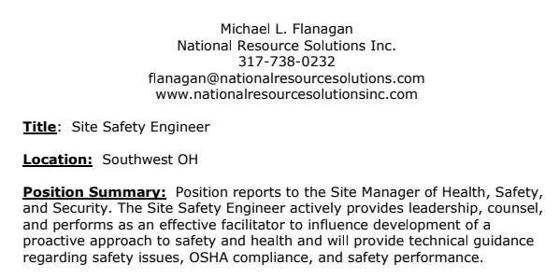
If you, or anyone else, has any questions I’m happy to address.
I appreciate all your help!

Regards,
“Specializing in Environmental, Health & Safety professional recruiting and placement”
Michael L. Flanagan
National Resource Solutions, Inc.
(317) 738-0232 office landline
(317) 604-3709 mobile/text
flanagan@nationalresourcesolutions.com
www.nationalresourcesolutionsinc.com
Linked In: www.linkedin.com/in/ michaelflanaganEHS

SAFETY CONTINUING EDUCATION OPPORTUNITIES
Safety Training / Professional Development Opportunities: June - September 2021

Mid America OSHA offers the most convenient and best OSHA training and education opportunities

Find courses below, Click on the date/location to learn more

Visit our Website

Multiple Industry Safety Education

OSHA 7505 - Intro to Incident / Accident Investigation
December 9 - Indianapolis, IN

BCSP- Professional Certification Workshop
November 18 - Cincinnati/Dayton, OH

OSHA 510 - OSHA Standards for Construction
(prerequisite for OSHA 500 Trainer Course)
November 15 - Cincinnati/Dayton, OH
﻿
OSHA 500 - OSHA Construction Trainer Course
November 9 - St. Clairsville, OH

OSHA 502 - Construction Trainer Update
November 17 - Indianapolis, IN

OSHA 501 - OSHA General Industry Trainer Course
November 29 - Cincinnati/Dayton, OH

OSHA 503 - OSHA General Industry Trainer Update
November 17 - Cincinnati/Dayton. OH
December 15 - Indianapolis, IN

OSHA 7005 - Warehousing and Storage
November 15 - Cincinnati/Dayton, OH

Online Courses
Prefer to do education on your own schedule?

We have over 300 online safety education opportunities

Click here to Review & Register

Certificate Program - Sign up & Save

‌
Safety Professional Certificate Program

This program is designed for a safety professional that strives for more knowledge, recognition and opportunities for advancement. Customizable for all industries.

Click here to learn more.
﻿

Welcome New Members

The South West Ohio Chapter of ASSP welcomes the following new members to ASSP. We appreciate their membership and hope they will join us as well as participate in our monthly meetings.

Nicole Long
Company Name - WORK: DHL
Job Title - Primary: Safety Specialist

Jared Crabb
Credentials: Construction Health & Safety Tech
Company Name - WORK: Beaty Construction Inc.

Albert Incerpi
Company Name - WORK: Ford

Rick Collins
Credentials: Construction Health & Safety Tech
Company Name - WORK: Turner Construction Company

Erika Napier
Company Name - WORK: Valiant Construction

Matt Stevens
Company Name - WORK: WENCO Construction Company LLC
Job Title - Primary: Safety Director

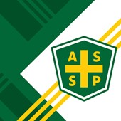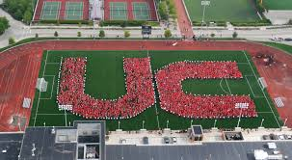
ATTENTION COLLEGE STUDENTS!
Membership | Education | Standards

18 Student Sections Honored
Jun 17, 2020
Our annual Outstanding Student Section Award recognizes and encourages the activities of established ASSP student sections at colleges and universities. The winning section receives $6,000 and a plaque. Student sections that meet the minimum criteria but not the award receive $500.
This year, we recognized 18 student sections:
- Murray State University – 1st Place
- Millersville University – 2nd Place
- Central Washington University – 3rd Place

California State University, Bakersfield
- East Carolina University
- Grand Valley State University
- Illinois State University
- Indiana State University
- Indiana University Bloomington
- Indiana University of Pennsylvania
- Oakland University
- Ohio University
- Oklahoma State University
- Oregon State University
- Slippery Rock University
- Southeastern Louisiana University
- Texas A&M University
- West Virginia University
Learn what it takes to become our Outstanding Student Section of the Year!

ATTENTION EMPLOYEERS:

We have a great connection with the University of Cincinnati in that our members want your students to help with coop and internship opportunities.

Here are the process steps if you want your organization to be included in the UC COOP placement program:
In order to recruit students for the next co-op term (fall semester), you will need to create an account in PAL, the database we use to manage the co-op program: www.uc.edu/PAL This is the best way to get real time access to resumes of students currently available and interested in your positions. I recommend stating the specific type of projects and equipment that students will be working on during the co-op in order to attract student interest.

The University of Cincinnati does ask that all co-op employers agree to:
1) Supervise the student for the duration of the semester
2) Provide full-time, paid work, as W2 employees during that time.
3) Agree that their organization is in compliance with state and federal
employment law and that their organization has and enforces non-
discrimination policies and has conduct policies in place.
4) Complete an evaluation of student performance at the end of the term (in
PAL).

In PAL you can select applicable majors/terms and the position will be viewable to students in the future. You can also find support materials, including co-op calendars and salary information, for co-op employers, including co-op calendars and salary information, on our website:
https://www.uc.edu/campus-life/careereducation/employers.html
2019-20 Average Co-op Salary

Students are currently applying for fall positions, but a rule of thumb for many co-op employers hiring is the following timeline:
- Summer semester: Hiring starts in January/February
- Fall semester: Hiring starts in April/May
- Spring semester: Hiring starts in August/September

Members please contact Annie Kelly to find out what students are available when and what their course of study is to better fit with your organization:

Annie Kelly, EdD (she/her/hers)
Visiting Assistant Professor
Mechanical Engineering Faculty Co-op Advisor - Class of 2023, 2024, & 2025
MechE Resources & Appointment Scheduling
Division of Experience-Based Learning & Career Education
University of Cincinnati
anne.kelly@uc.edu

Newsletter additions or comments:
David Schriever, M.S., CSP
NE Regional EHS Manager
Cox Automotive
Daviator95@gmail.com
513-375-3743
CONFIDENTIALITY NOTE: The information contained in this transmission is for the exclusive use of the addressee and may contain confidential, privileged, and non-disclosable information. If the receipt of this transmission is not the addressee, such recipient is strictly prohibited from reading, distributing, or otherwise using this transmission or its contents in any way.

