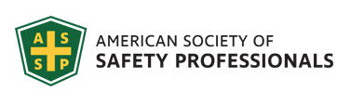
Southwestern Ohio Chapter News & Meeting Announcement – January 2021
Scheduled Meetings and Topics for 2021
January No Meeting
February Environmental Overview for the Safety Professional

March Matt Summers (Area Director for Central Region ASSP) Workplace Violence
April Ronald McDonald House – Member Volunteer Outreach Opportunity
May OSHA Discussion

Won’t you please join us (VIRTUALLY)?
Date: Tuesday February 9th
Call In Meeting time: 11:45 AM – 1:00 PM
Location: online Please register online: https://swohio.assp.org/event/
After you register, you will be notified a couple of days prior to the meeting via e-mail for the invite and meeting access details.
If you cannot join us for the online workshop, please check out our resources page online.
February topic will be titled: “Environmental Overview for the Safety Professional”

Presenter:
Rajib Sinha, P.E.
Senior Project Manager/Engineer
Trihydro

JANUARY MEETING TOPIC:
Central Indiana Chapter of the ASSP Chapter Meeting this Month
When: Friday, Jan 8, 2020, 11:00 a.m. to 12:00 p.m.
Speaker: The Safety Justice League: Abby Ferri, Jason Lucas and Jason Maldonado
Location: Click here to Join Zoom Meeting
Register at: January Chapter Meeting – ASSP Central Indiana Chapter
Topic: Branding Safety – A Journey into the Future of Safety Influence
In this session you will experience a wild ride into the future and learn what it takes to build a brand in the post-millennial era. Emails, uninteresting meetings, and old-school networking just don’t work anymore. If you want to succeed in this (or any) profession these days, you need to build a reputation, NOT a resume! Join three maverick Safety and Health branding specialists to learn what you need to build your brand and make safety make sense for any business in today’s modern age.
CEU Points: You will earn .10 IACET approved CEU Points for attending this technical meeting. A certificate of completion will be emailed to you for your records after completing the post-evaluation.
The Louisville Chapter
Topic Pandemic Planning for the OSH Professional
In the Spring of 2020, The National Institute for Occupational Safety and Health (NIOSH), and the Centers for Disease Control and Prevention (CDC) anticipated a greater need for occupational safety and health technical assistance to combat COVID-19 as workplaces start to resume on-site operations. NIOSH anticipates that the need for technical assistance will affect the entire United States, last for the duration of the COVID-19 pandemic, and exceed current NIOSH capacity. OSH professionals need assistance on how best to decrease the spread of COVID-19 and lower the impact on workplaces. This brief will discuss the current plans and resources that will be available to OSH professionals, specifically pandemic/infectious disease workplace plans.
Speakers Gary A. Morris, PhD, CSP
Gary A. Morris, PhD, CSP is an Associate Professor (Tenured) in the Department of Occupational Safety & Health at Murray State University. He retired as an Industrial Hygiene Officer in 2012 after serving 20 years in the United States Navy. He earned his doctorate from Old Dominion University in 2003 and is a Professional Member of ASSP.
Agenda
11:45 Meeting open to Attendees & Networking
12:00 Presentation begins
1:00 Meeting ends
https://louisville.assp.org/events/assp-louisville-chapter-virtual-meeting-6/

CHATTANOOGA CHAPTER All registered are welcome to attend
MEETING: January 22nd at 9:00 AM Eastern Time Zone
Registration is on their website: https://chattanooga.assp.org/events/january-2021-chapter-meeting/?
I want to invite you to a special chapter meeting in January with special guest presenter
Wayne Morris with the Fire Prevention Division of the Tennessee State Fire Marshall’s Office.
Wayne Morris became a part of the Tennessee Fire & Codes Academy Team in 2006 after moving to Tennessee from South Mississippi as a Fire Service Instructor and Fire Program Supervisor in 2010, and became the Fire Prevention/Codes Enforcement Program Supervisor in 2018. He currently serves as Plans Examiner Supervisor with the Tennessee State Fire Marshal’s Office.
Wayne is a Tennessee State advocate for the National Fallen Firefighters Association, a liaison Board Member for Tennessee Public Fire Educators Association, and Instructor partner with the Federal Highway Administration/ Tennessee Department of Transportation to deliver National Traffic Incident Management Program.
Combustible Dust: Proactive Prevention
Description: This presentation is designed to provide the Safety Professional with the knowledge and skills needed to successfully educate industrial workers with life safety information of specific hazards in the industrial plant. For those who are responsible for fire and life safety education, safety management, and elimination of hazards. Combustible Dust is the focus, recognition of hazards, best practices to eliminate the hazard, and procedure and policy decisions to prevent a disaster by working proactively v/s reactively , and personnel involved in education on the risks in the industrial setting, with information to assist in the reduction of fire and explosions risks.
When: January 22, 9:00am
Online: Join Microsoft Teams Meeting
+1 470-427-2623 United States, Atlanta (Toll)
Conference ID: 441 778 609#
Please register on our ASSP Chapter page and join our Teams Call on January 22nd!

A Message from our Chapter President; Brad Weber

I wanted to recognize our new online members. We at the South West Ohio Chapter of ASSP would like to extend a warm welcome and cordially invite you to attend our monthly Chapter meetings. We hope to see you virtually at our next meeting.
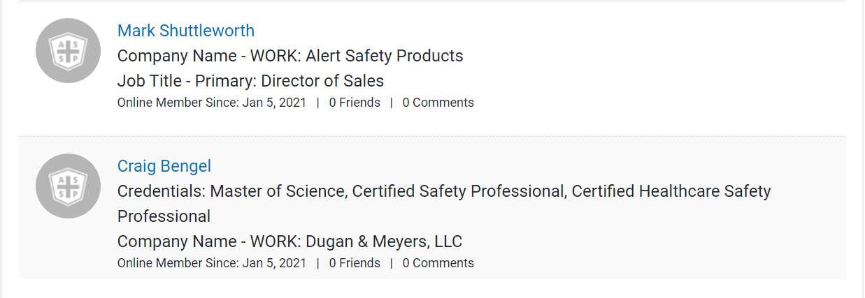

Volunteer Opportunity:
Clay Shooting Fundraiser
We need volunteers to help organize and set-up a clay shoot fundraiser.
The following is a link to a survey tool to help us identify if the fund raiser is of value to you and if you are interested in participating in the event.
https://form.jotform.com/202585223208046

OTHER OUTREACH OPPORTUNITES:
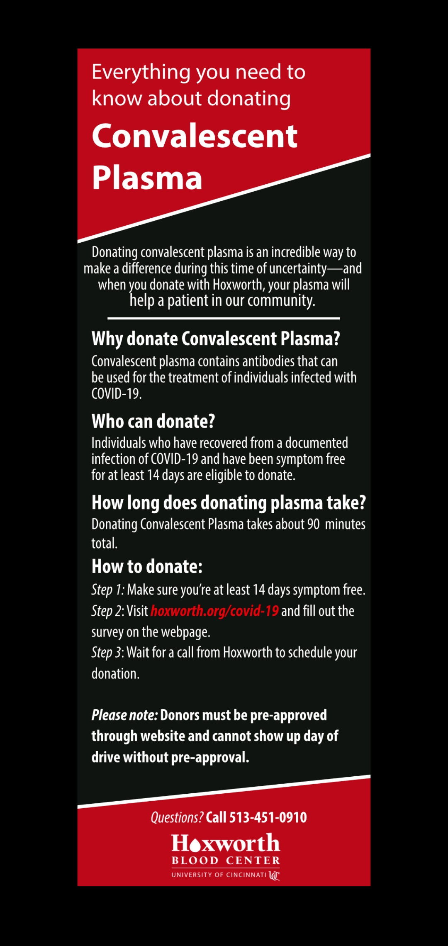
Welcome to the January 2021 issue of Society Update, a benefit of your ASSP membership that highlights the latest Society news, activities, upcoming events, and notable member and community achievements. Submit your news or questions/comments to societyupdate@assp.org.

TOP STORIES
ASSP Responds to New BLS Fatality Data
The Society is urging employers to be more active in adopting voluntary national consensus standards and implementing safety and health management systems in response to newly released fatality data from U.S. Bureau of Labor Statistics.
LEARN MORE

Revised Standard Improves Safety of Construction & Demolition Workers
A newly revised standard, ANSI/ASSP A10.33-2020, Safety and Health Program Requirements for Multiemployer Projects, helps employers keep construction workers safe by describing best practices they can implement to take safety programs to the next level.
LEARN MORE

Anil Mathur Recognized for Safety Excellence by Washington Governor
Anil Mathur, ASSP's Public Director, was recognized by Washington Governor Jay Inslee for his commitment to safety, service and environmental stewardship during his career.
LEARN MORE

Sponsored Ad Content
Ice Cleats That Can Be Left On Indoors & While Driving
Transitional Traction ice cleats are designed for employees who are often the most difficult to provide traction for; those who frequently transition from outdoors to indoor settings and/or drive vehicles. Transitional Traction devices can be left on all day without the need to be removed each time you walk indoors.
LEARN MORE
MORE NEWS
ASSP Develops Free Live Virtual Events
Join fellow OSH professionals at ASSP's live virtual events, which are free to members, on Jan. 26 - 27, 2021.
LEARN MORE

ASSP Practice Specialties Host January Webinars
ASSP's practice specialties and common interest groups regularly host webinars, which are open to all ASSP members and nonmembers. The goal is to provide educational discussions for participants, as well as to share the benefits of these networking groups.
LEARN MORE

Refer New Members in the Annual Member-Get-A-Member Campaign
ASSP's annual member referral program returns in 2021. Share the resources ASSP offers with colleagues by using the Refer-A-Friend email tool or directing potential members to the ASSP website to encourage them to join the Society.
LEARN MORE

ASSP Members Reached Safety Milestones in 2020
In 2020, these members reached significant years of ASSP membership and service. Thank you for your continued support of the Society and the OSH profession.
LEARN MORE

Managing Safety on Multiemployer Work Sites

Multiemployer construction projects create many safety challenges. Multiple companies often end up working together, which raises important safety questions. Check out these resources that can help you create and manage safety programs on shared construction sites.
Read the article Managing Safety on Multiemployer Work Sites to learn the four keys to successfully managing a safety program on a busy construction site.

Download the ANSI/ASSP A10.33 overview document to learn how this new standard can be your guide to creating a safer shared work site.

Listen to our podcast Construction and Demolition Operations with John Johnson, chair of the ANSI/ASSP A10 committee, as he explains how the A10 standards can help reduce risk and improve productivity on construction sites.

Access Construction Resources

Online Education
Take $150 off the Fall Protection Equipment Course with promo code FPE150 (expires 12/31/20)
Fall Protection Equipment Course
Online Self-Paced Course | 3.0 CEUs
Develop your knowledge of the most common types of fall protection equipment-including anchorage connectors, full body harnesses, personal energy absorbing lanyards and self-retracting devices-and gain expert guidance on implementing each component in alignment with the current ANSI/ASSP Z359 standards. Your registration includes four ANSI/ASSP Z359 standards - a $600 value. Learn more
NEW! Pre-Planning for OSH Performance on Construction and Demolition Sites
Online Self-Paced Course | 0.5 CEUs
Learn how to integrate pre-project and pre-task safety and health planning into all your projects. Intended for OSH professionals, construction owners, project constructors and contractors, this course includes a five ANSI/ASSP A10 construction and demolition standards including the new A10.33 standard - a $550 value. Learn more

January 7 - February 3, 2021
Implementing ISO 45001
Online Course | 2.1 CEUs
The ISO 45001 online course provides learners with the knowledge and confidence to successfully implement the standard. Your registration includes a copy of ANSI/ASSP/ISO 45001-2018 - a $135 value. Learn more

January 7 - February 11, 2021
Managed Fall Protection
Online Course | 2.1 CEUs
Build the knowledge you need to implement a comprehensive managed fall protection program supported by the included standard: ANSI/ASSP Z359.2-2017, Minimum Requirements for a Comprehensive Managed Fall Protection Program - a $150 value. Learn more

January 10 - February 14, 2021
Internal OHSMS Auditing Using ISO 45001
Online Course | 3.0 CEUs
Develop a solid understanding of audit programs and processes and know how to complete an audit of your occupational health and safety management system (OHSMS). Your registration includes a copy of ANSI/ASSP/ISO 45001-2018 - a $135 value. Learn more
Invest in Yourself in 2021

As we come to the end of a difficult year, we reflect on what gives us hope for the future. And safety professionals like you are on the top of our list. You are passionate about creating safe work environments for employees, and ASSP is here to support you as you progress in your career. Your ASSP membership provides resources and tools you can access all year to invest in yourself and reach your full leadership potential!

Articles

Safety Leadership Checklist: Do You Have What It Takes?
Safety leadership is a mindset and a skill set that is essential for protecting others on the job. Do you have what it takes? Use this checklist to find out. Read More

Changing the Game in Safety Performance: The Leader's Role
This article explores how to apply the best practices of the world's top safety leaders to achieve dramatic safety performance improvement. Read More

5 Reasons Improving Safety Culture Is a Business Skill
Improving safety culture has personal, professional and financial implications for everyone in your organization. Here are five reasons it's worthy of respect. Read More

Free Webinars
The New View: Safety Professionals as Change Agents
A challenge for any organization is how to initiate, implement and sustain change. As a safety professional, you can be a change agent. Explore change management tools and methods and take away tips to help build your competencies in leading effective safety change. Watch Now

Getting a Seat in the C-Suite: What Every Safety Pro Should Know
Learn the indispensable tactics every safety professional needs to be effective. Hear how to connect with senior leadership at your organization and learn everything you've been missing when it comes to communicating with your senior leadership.
Watch Now

Courses
- On Demand: Leadership for OSH Excellence With or Without Direct Authority
- On Demand: Business Skills and Leadership Sessions
- SafetyFOCUS 2021 Business Skills and Leadership Courses
- SafetyFOCUS 2021 Training and Education Course
ATTENTION COLLEGE STUDENTS!

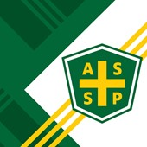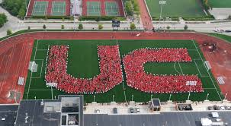
Student Chapter Section:
SPEAKERS NEEDED FOR MEETINGS:
If you are working in the Environmental Health and Safety field and would like to share your experience with our Student Section, please contact Dave Schriever at daviator95@gmail.com.
If you are attending the university of Cincinnati and would like to join our student section of ASSP, please contact Professor Kim Jay, PhD Mechanical engineering, Rhodes Hall 598B University of Cincinnati, (513) 555-6300, jay.kim@uc.edu, and or Brad Weber to find out more and become a Student Member today.

Newsletter additions or comments:
David Schriever, M.S., CSP
NE Regional EHS Manager
Cox Automotive
Daviator95@gmail.com
513-375-3743

CONFIDENTIALITY NOTE: The information contained in this transmission is for the exclusive use of the addressee and may contain confidential, privileged and non-disclosable information. If the receipt of this transmission is not the addressee, such recipient is strictly prohibited from reading, distributing or otherwise using this transmission or its contents in any way.

