Southwestern Ohio Chapter News & Meeting Announcement – February 2020
Scheduled Meetings and Topics for 2020
February 11th Tour of Continental Building Products (register on ASSP website)
March 6th Volunteer Event @ Ronald McDonald House 14 spaces available (Friday evening register early)
March 11-13th Ohio Safety Congress (Columbus, Ohio)
April 14th Annual Strategic Planning Meeting – Sheakly Building
May 14th Ken Montgomery, OSHA Area Director Joint meeting with AIHA – at Sheakly Bldg.
June TBD Member appreciation night – at Florence Freedom game
June 23-25th ASSP PDC Orlando, FL
July NO MEETING

Won’t you please join us!
Its not too late too register for the upcoming tours. Go to the ASSP website to be included.
Its not too late to register for Tuesday’s tour at Continental Building Products!
Agenda: Arrival and Registration 11:15 AM
Lunch Served 11:15 – 11:45 AM Presentation 11:45 – 12:45 PM
Q & A and Adjournment 12:45 – 1:00 PM
Location: Sheakley Group of Companies Offices (meet greeter in lobby)
One Sheakley Way, Cincinnati OH 45246

January Group shot at Perfetti Van Melle

Cost: $10 for Chapter Members and guests if prepaid (lunch provided,
ask if vegetarian option is preferred); $15 if paid at the door – no meal
Please register and pay online at http://swohio.asse.org
Thanks to the team at Perfetti Van Melle for a great tour and treats!
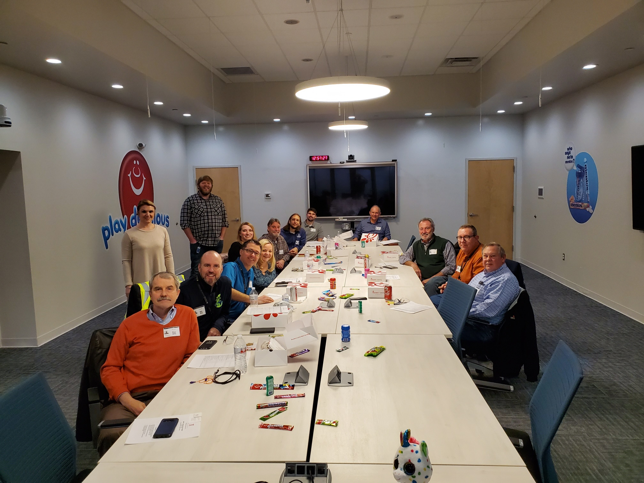

FEBRUARY TOUR AT
Continental Building Products:
Formerly Lafarge Gypsum, Continental Building Products is a North American leader in wallboard and joint compound materials. 5145 Mary Ingles Hwy, Silver Grove, Silver Grove, Kentucky, 41085

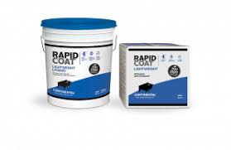

Its not too late to register for the tour. Go to the our website to attend: https://swohio.assp.org/events/plant-tour-continental-building-products/

Professional Safety Magazine
https://www.assp.org/publications/professional-safety
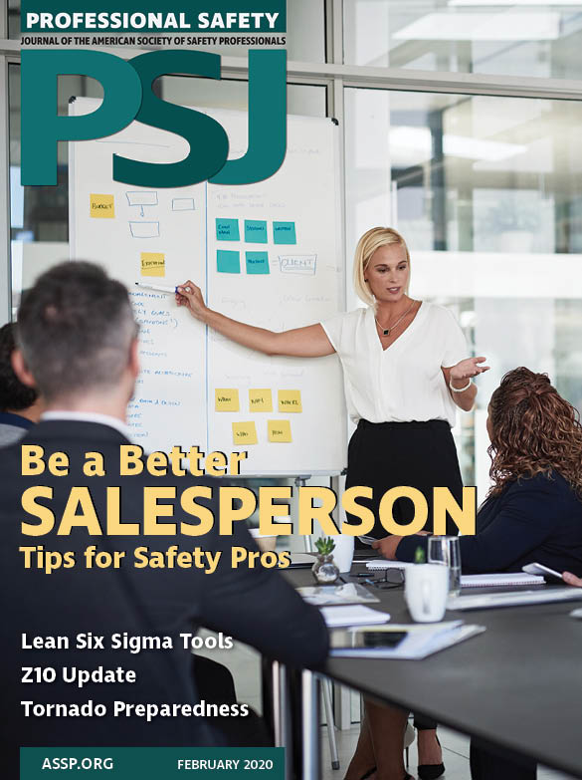
From our latest issue:

Professional Issues
Four Reasons OSH Professionals Must Be Better Salespeople
By Matt Law

Standards Insider
Establishing A Safety Management System With Z10
Q&A With Jim Howe & Amy Timmerman

Best Practices
Plan-Do-Check-Act: Integrating Quality Into Safety Management
By Art Williams

PSJ Asks
Tornado Preparedness
Q&A With Jim Gustin, Travelers

Want to add a little excitement to you safety meetings? Go to the ASSP web site and look at the

PSJ Photo Gallery
This is not the best way to begin your New Year’s 5S Resolution:

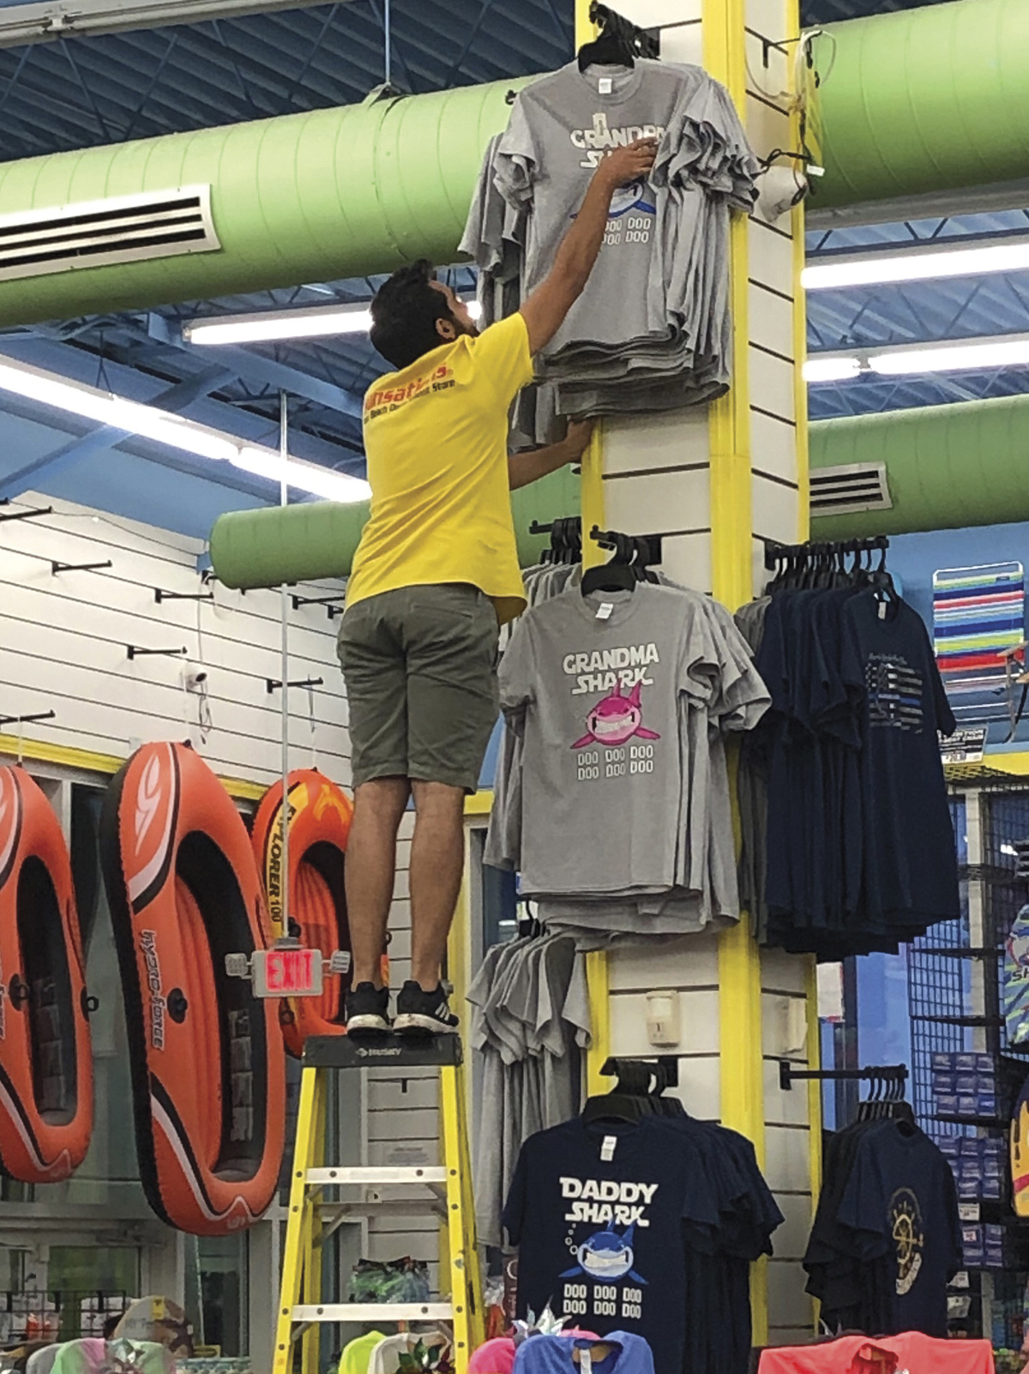

SAVE THE DATE!
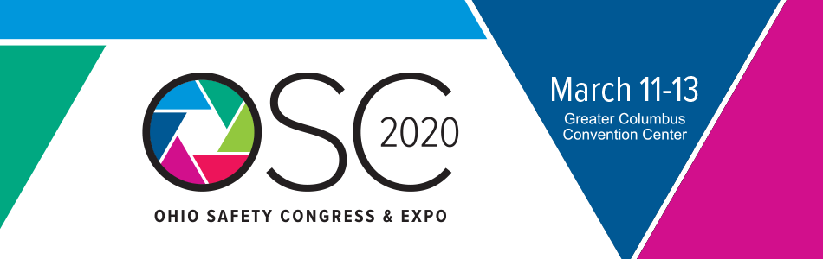
Newsletter additions or comments:

David Schriever, M.S., CSP
NE Regional EHS Manager
Cox Automotive
Daviator95@gmail.com
513-375-3743

CONFIDENTIALITY NOTE: The information contained in this transmission is for the exclusive use of the addressee and may contain confidential, privileged and non-disclosable information. If the receipt of this transmission is not the addressee, such recipient is strictly prohibited from reading, distributing or otherwise using this transmission or its contents in any way.

