Southwestern Ohio Chapter
News & Meeting Announcement – November 2019
Scheduled Meetings and Topics for 2019 and 2020

November 12th Active Shooter Lunch and Learn (SPECIAL TIME 11-1)
December 3rd Member appreciation/Vendor night - Ohio BWC building
135 Merchant St. Cint., Oh. 45246
2020

January or February Tour of Continental Building Products (NO MEETING)
March 6th Volunteer Event @ Ronald McDonald House (Friday evening register early)
March 11-13th Ohio Safety Congress (Columbus, Ohio)
April 14th Annual Strategic Planning Meeting
May 12th Ken Montgomery, OSHA Area Director Joint meeting with AIHA
June TBD Member appreciation night
June 23-25th ASSP PDC Orlando, FL

Won’t you please join us!

Agenda: Arrival and Registration 11:15 AM

Lunch Served 11:15 – 11:45 AM

Presentation 11:45 – 12:45 PM

Q & A and Adjournment 12:45 – 1:00 PM

Location: Sheakley Group of Companies Offices (meet greeter in lobby)
One Sheakley Way, Cincinnati OH 45246

Cost: $10 for Chapter Members and guests if prepaid (lunch provided,
ask if vegetarian option is preferred); $15 if paid at the door – no meal
Please register and pay online at http://swohio.asse.org

Special Lunch & Learn in November

November 12th our ASSP Chapter is hosting a lunch and learn covering Active Shooter.
event. This topic is ever changing and there are always new developments to learn and share. Call or go online to register. DON’T FORGET: THERE IS A FREE LUNCH for members.

Thanksgiving is Thursday November 28th. Here are a few safety tips for you and your family.

Thanksgiving Fire Safety Tips

- Never leave the food during frying, on stove/oven – the most important Thanksgiving dinner safety tips.
- Set up a timer on your phone as a reminder to check the cooking process.
- Use a quality turkey fryer and use it outside your home.
- Keep your children and pets away from the cooking area.

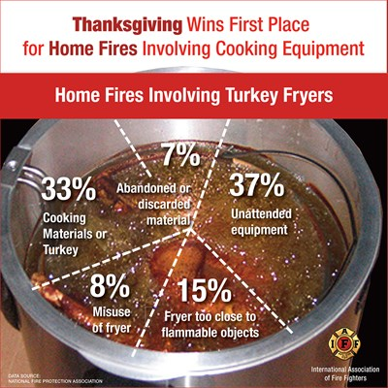

Newsletter additions or comments:

David Schriever, M.S., CSP
Assurance Risk Management, LLC
david@assuranceriskmanagement.net
513-375-3743

CONFIDENTIALITY NOTE: The information contained in this transmission is for the exclusive use of the addressee and may contain confidential, privileged and non-disclosable information. If the receipt of this transmission is not the addressee, such recipient is strictly prohibited from reading, distributing or otherwise using this transmission or its contents in any way.

