Southwestern Ohio Chapter
News & Meeting Announcement – September 2019
Scheduled Meetings and Topics for 2019

September 10th Fall Protection with Brian Canteel
October 2019 Safety Leadership & Best Practices – Jonathan Zimmerman
November 12th Social gathering at Little Miami Brewing – Evening TBD
December 3rd Member appreciation/Vendor night - Time TBD
January Tour of Continental Building Products (may occur in Feb TBD)
February open
March open
April open
May 12th Ken Montgomery, OSHA Area Director Joint meeting with AIHA

Won’t you please join us!

Agenda: Arrival and Registration 11:15 AM

Lunch Served 11:15 – 11:45 AM

Presentation 11:45 – 12:45 PM

Q & A and Adjournment 12:45 – 1:00 PM

Location: Sheakley Group of Companies Offices (meet greeter in lobby)
One Sheakley Way, Cincinnati OH 45246

Cost: $10 for Chapter Members and guests if prepaid (lunch provided,
ask if vegetarian option is preferred); $15 if paid at the door – no meal
Please register and pay online at http://swohio.asse.org

Member Appreciation/Vendor Night

Tuesday December 3rd there will be a joint member appreciation/Vendor night with the local AIHA chapter held at the BWC Springdale office (135 Merchant Street, Cincinnati, Ohio 45246.
In upcoming newsletters, there will be more details and timing of this event.

Now is the time for those of you who have some exciting and timely information to share with your fellow Chapter members to sign up for one of the regularly scheduled monthly meetings and present. This is a great way to share your information and meet fellow Chapter members. Please let me know and I will forward the information to the board for submission into the schedule.

Remember to keep your saw sharp and the best way to do that is to log on to the National ASSP website and see what they have to offer. Here are a couple recent screen shots that may be helpful:

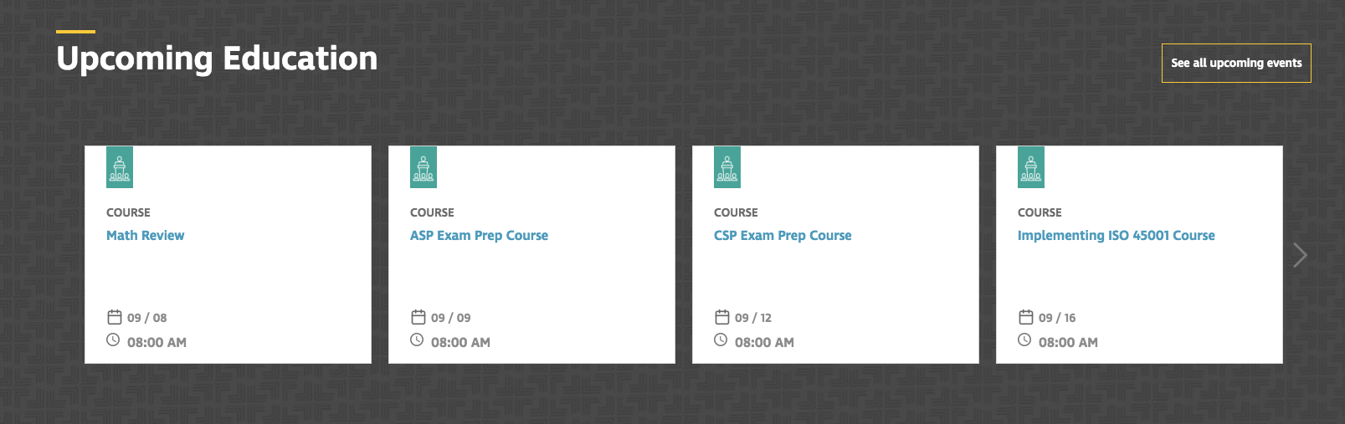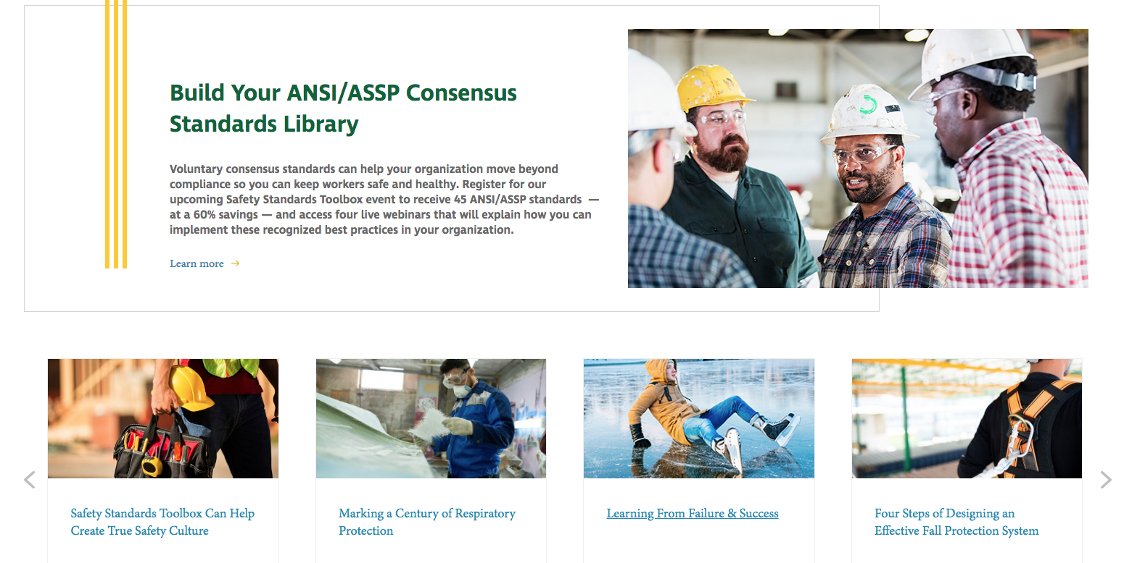

Newsletter additions or comments:

David Schriever, M.S., CSP
Assurance Risk Management, LLC
david@assuranceriskmanagement.net
513-375-3743

CONFIDENTIALITY NOTE: The information contained in this transmission is for the exclusive use of the addressee and may contain confidential, privileged and non-disclosable information. If the receipt of this transmission is not the addressee, such recipient is strictly prohibited from reading, distributing or otherwise using this transmission or its contents in any way.

