Southwestern Ohio Chapter
News & Meeting Announcement – July, 2019
Scheduled Meetings and Topics for 2019

February ANSI update from Stan Brubaker
March ISO 450001 with Jonathan Zimmerman
April 12 Ronald McDonald House (Volunteer Opportunity)
May 2nd & 3rd Regional Operating Committee meeting hosted by SW Ohio Chapter
June 14th Member Appreciation Event at Florence Freedom
July The executive board decided No Meeting This Month
August 13th Annual strategic planning meeting for all to attend
September 10th Fall Protection with Brian Canteel
October 2019 Social Event being planned date TBD
November 12th open
December 10th open

Won’t you please join us!

Agenda: Arrival and Registration 11:15 AM

Lunch Served 11:15 – 11:45 AM

Presentation 11:45 – 12:45 PM

Q & A and Adjournment 12:45 – 1:00 PM

Location: Sheakley Group of Companies Offices (meet greeter in lobby)
One Sheakley Way, Cincinnati OH 45246

Cost: $10 for Chapter Members and guests if prepaid (lunch provided,
ask if vegetarian option is preferred); $15 if paid at the door – no meal
Please register and pay online at http://swohio.asse.org

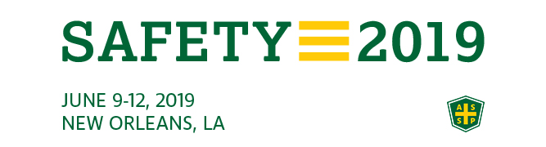

Please forward any great learning’s and funny clips from the conference to add to our next month’s newsletter.

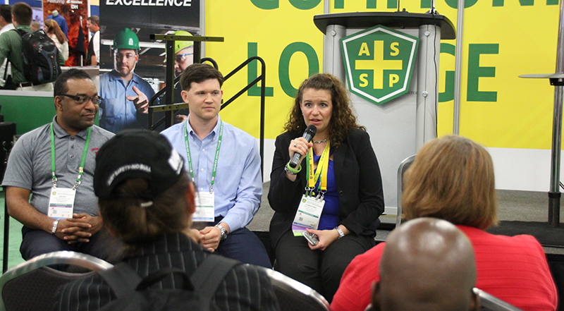

There were great networking opportunities and great deals in the ASSP store. All had great learnings and good times.
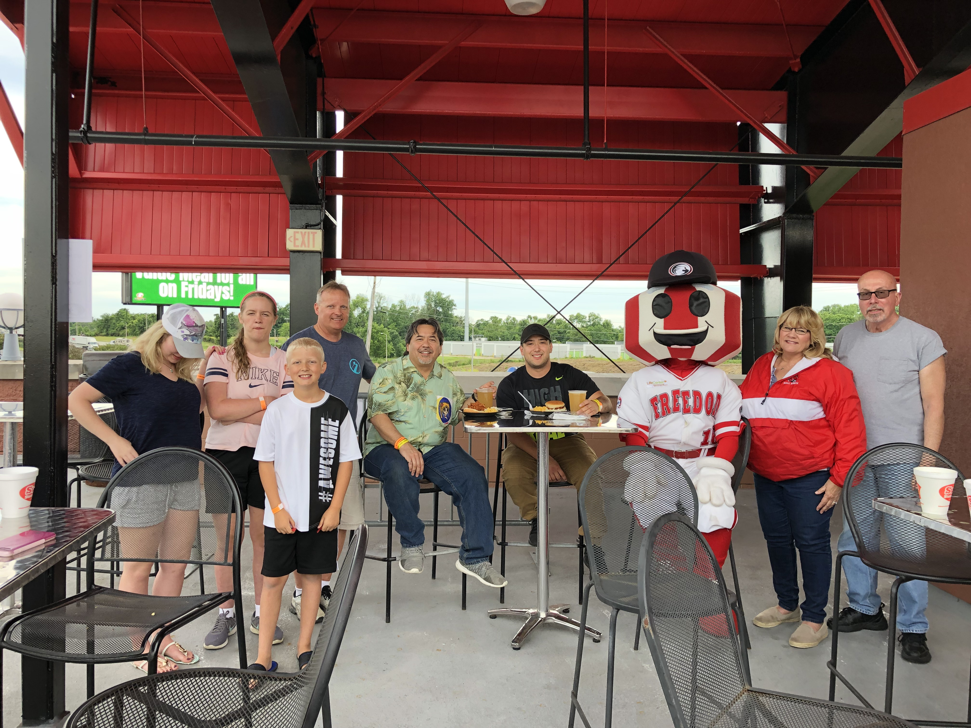

Membership Appreciation Night:

Friday June 14, 2019 was a great day at the ballpark. We were in the blue section that is covered. There was a buffet meal and drinks, Star Wars theme night and Fireworks after the game. This event was great for the entire family.

Thank you SW Ohio ASSP Chapter for sponsoring this years Member Appreciation night out!

Newsletter additions or comments:

David Schriever, M.S., CSP
Assurance Risk Management, LLC
david@assuranceriskmanagement.net
513-375-3743

CONFIDENTIALITY NOTE: The information contained in this transmission is for the exclusive use of the addressee and may contain confidential, privileged and non-disclosable information. If the receipt of this transmission is not the addressee, such recipient is strictly prohibited from reading, distributing or otherwise using this transmission or its contents in any way.

