Southwestern Ohio Chapter
News & Meeting Announcement – June, 2019
Scheduled Meetings and Topics for 2019

February ANSI update from Stan Brubaker
March ISO 450001 with Jonathan Zimmerman
April 12 Ronald McDonald House (Volunteer Opportunity)
May 2nd & 3rd Regional Operating Committee meeting hosted by SW Ohio Chapter
June 14th Member Appreciation Event at Florence Freedom
July The executive board decided No Meeting This Month
August 13th Annual strategic planning meeting for all to attend
September 10th Fall Protection with Brian Canteel
October 2019 Social Event being planned date TBD
November 12th open
December 10th open

Won’t you please join us!

Agenda: Arrival and Registration 11:15 AM

Lunch Served 11:15 – 11:45 AM

Presentation 11:45 – 12:45 PM

Q & A and Adjournment 12:45 – 1:00 PM

Location: Sheakley Group of Companies Offices (meet greeter in lobby)
One Sheakley Way, Cincinnati OH 45246

Cost: $10 for Chapter Members and guests if prepaid (lunch provided,
ask if vegetarian option is preferred); $15 if paid at the door – no meal
Please register and pay online at http://swohio.asse.org

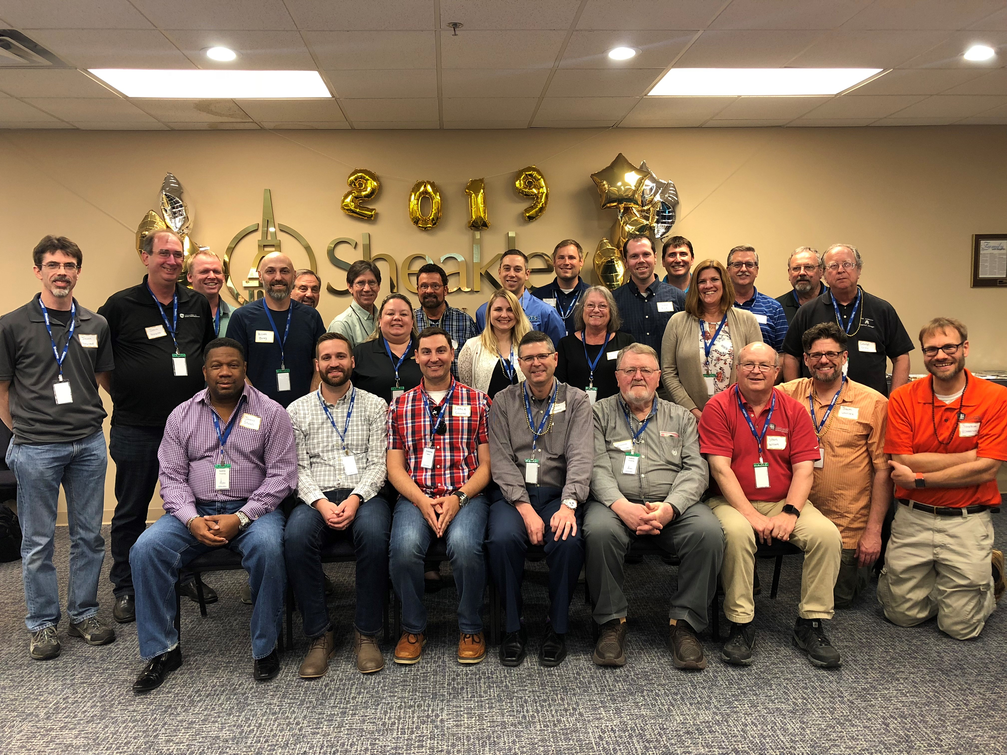
Region’s 7 Spring Regional Operating Committee (ROC) meeting
May 2-3 (Thu-Fri) in Cincinnati, OH.

The SW Ohio Region hosted the ROC event, which took place on May 2nd and 3rd. It started with an exclusive behind-the-scenes safety and security tour of Kings Island Amusement Park. Late the team enjoyed some networking after all the meetings were finished at Rhine Geist brewery in Over the Rhine historical district in Cincinnati. There the brewery provided an overview of brewing history as well as a tour of the facility and it’s processes.

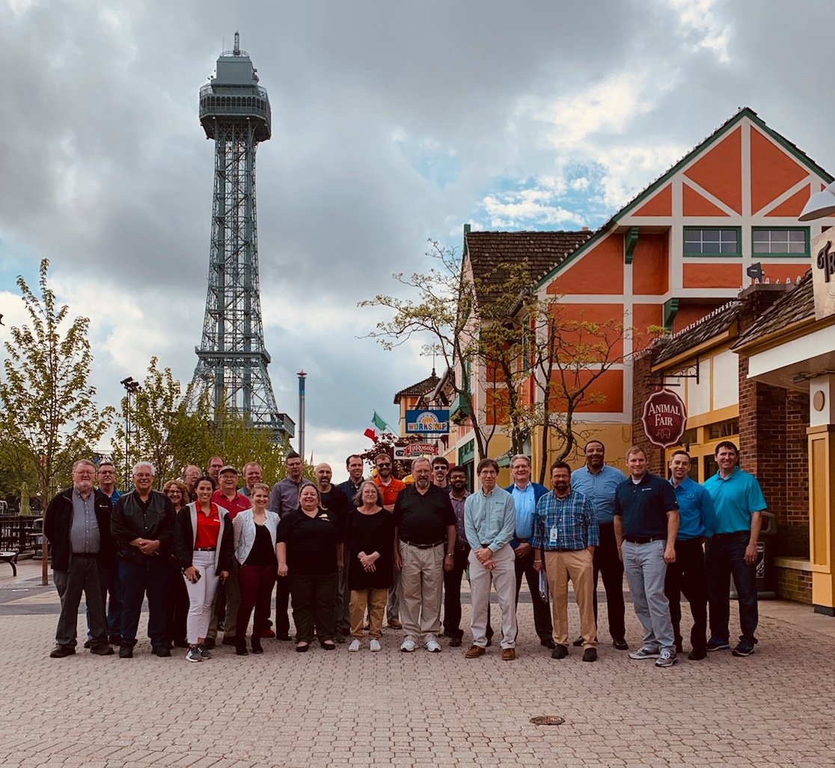

Membership Appreciation Night: 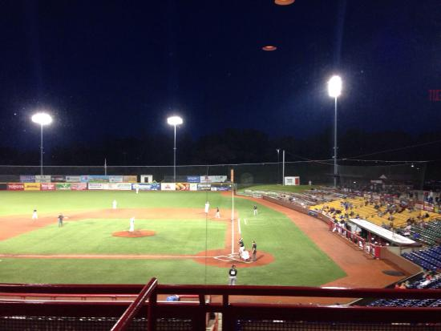

We are booked for Friday June 14, 2019. We are in the blue section that is covered. There is a buffet meal and drinks, Star Wars theme night and Fireworks after the game. This event will be great for the entire family.

COST: Member and 1 guest is no cost and any others are $10 each

See https://www.florencefreedom.com/

Florence Freedom
UC Health Stadium
7950 Freedom Way
Florence, Kentucky 41042

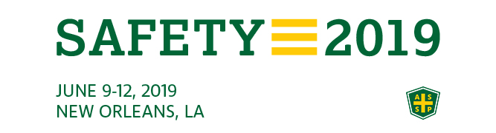

Please forward any great learning’s and funny clips from the conference to add to our next month’s newsletter.

Newsletter additions or comments:

David Schriever, M.S., CSP
Assurance Risk Management, LLC
david@assuranceriskmanagement.net
513-375-3743

CONFIDENTIALITY NOTE: The information contained in this transmission is for the exclusive use of the addressee and may contain confidential, privileged and non-disclosable information. If the receipt of this transmission is not the addressee, such recipient is strictly prohibited from reading, distributing or otherwise using this transmission or its contents in any way.

